February 2025
Products & Services
Esthetic printing in VITA quality:
New VITA VIONIC RESINS for your digital workflow
As of April 2025, VITA Zahnfabrik will be expanding its range of products for digital prosthetics with the innovative 3D printing materials from the VITA VIONIC SOLUTIONS portfolio. The new VITA VIONIC RESINS offer users high-quality materials and reliable shades, making 3D printing in the laboratory cost-efficient and dependable.
A seamless workflow from a single source
With VITA VIONIC RESINS, a completely printed workflow becomes reality: from VITA VIONIC TRY-IN RESIN for try-ins to the definitive denture base with VITA VIONIC BASE RESIN IMPACT, to the tooth elements made from VITA VIONIC DENT RESIN and the final customization. This workflow is at the heart of the new VITA VIONIC ECONOMY level, making it possible to print dentures quickly, efficiently and with impressive quality, saving both time and money.
VITA VIONIC BASE RESIN IMPACT – impact-resistant and durable
VITA VIONIC BASE RESIN IMPACT offers a new level of quality for fabricating final denture bases. Thanks to its durability, the material has a high load capacity and a low risk of fractures. The balanced property profile promises long-lasting results. VITA VIONIC BASE RESIN IMPACT will be available at IDS 2025 in pink and pink translucent, each in 1 kg sizes.
VITA VIONIC DENT RESIN – PERFECT MATCH in shade and quality:
VITA VIONIC DENT RESIN is used to create highly abrasion-resistant, shade-stable dental arches and elements: as of April 2025, resins in eight VITA classical A1–D4 shades and the bleach shade 0M3 will be available. Thanks to its high strength, the new resin is suitable for final dentures, as well as temporary crowns and bridges. The very low wear values of the printed denture teeth made with VITA VIONIC DENT RESIN, make them comparable to milled work in terms of durability
VITA VIONIC TRY-IN RESIN – for precise try-ins
The new VITA VIONIC TRY-IN RESIN completes the portfolio. It is an ideal material for functional try-ins in partial and full dentures. It offers fast and material-efficient production and easy processing. It also sets new standards for durability, thanks to its long shelf life of three years.
Taking digital prosthetics to the next level with VITA VIONIC RESINS
The materials in the VITA VIONIC SOLUTIONS portfolio stand for innovation and efficiency. They support dental technicians and dentists in meeting their individual requirements for future, modern prosthetics, as well as optimizing their workflow over the long-term. Whether it’s printing, milling or a mix of both, VITA offers the right products for your digital workflow. The results range from highly esthetic to highly cost effective – always with the best material quality and the PERFECT MATCH to the VITA shade guide.
More information about the new VITA VIONIC RESINS can be found on the website: VITA Zahnfabrik.

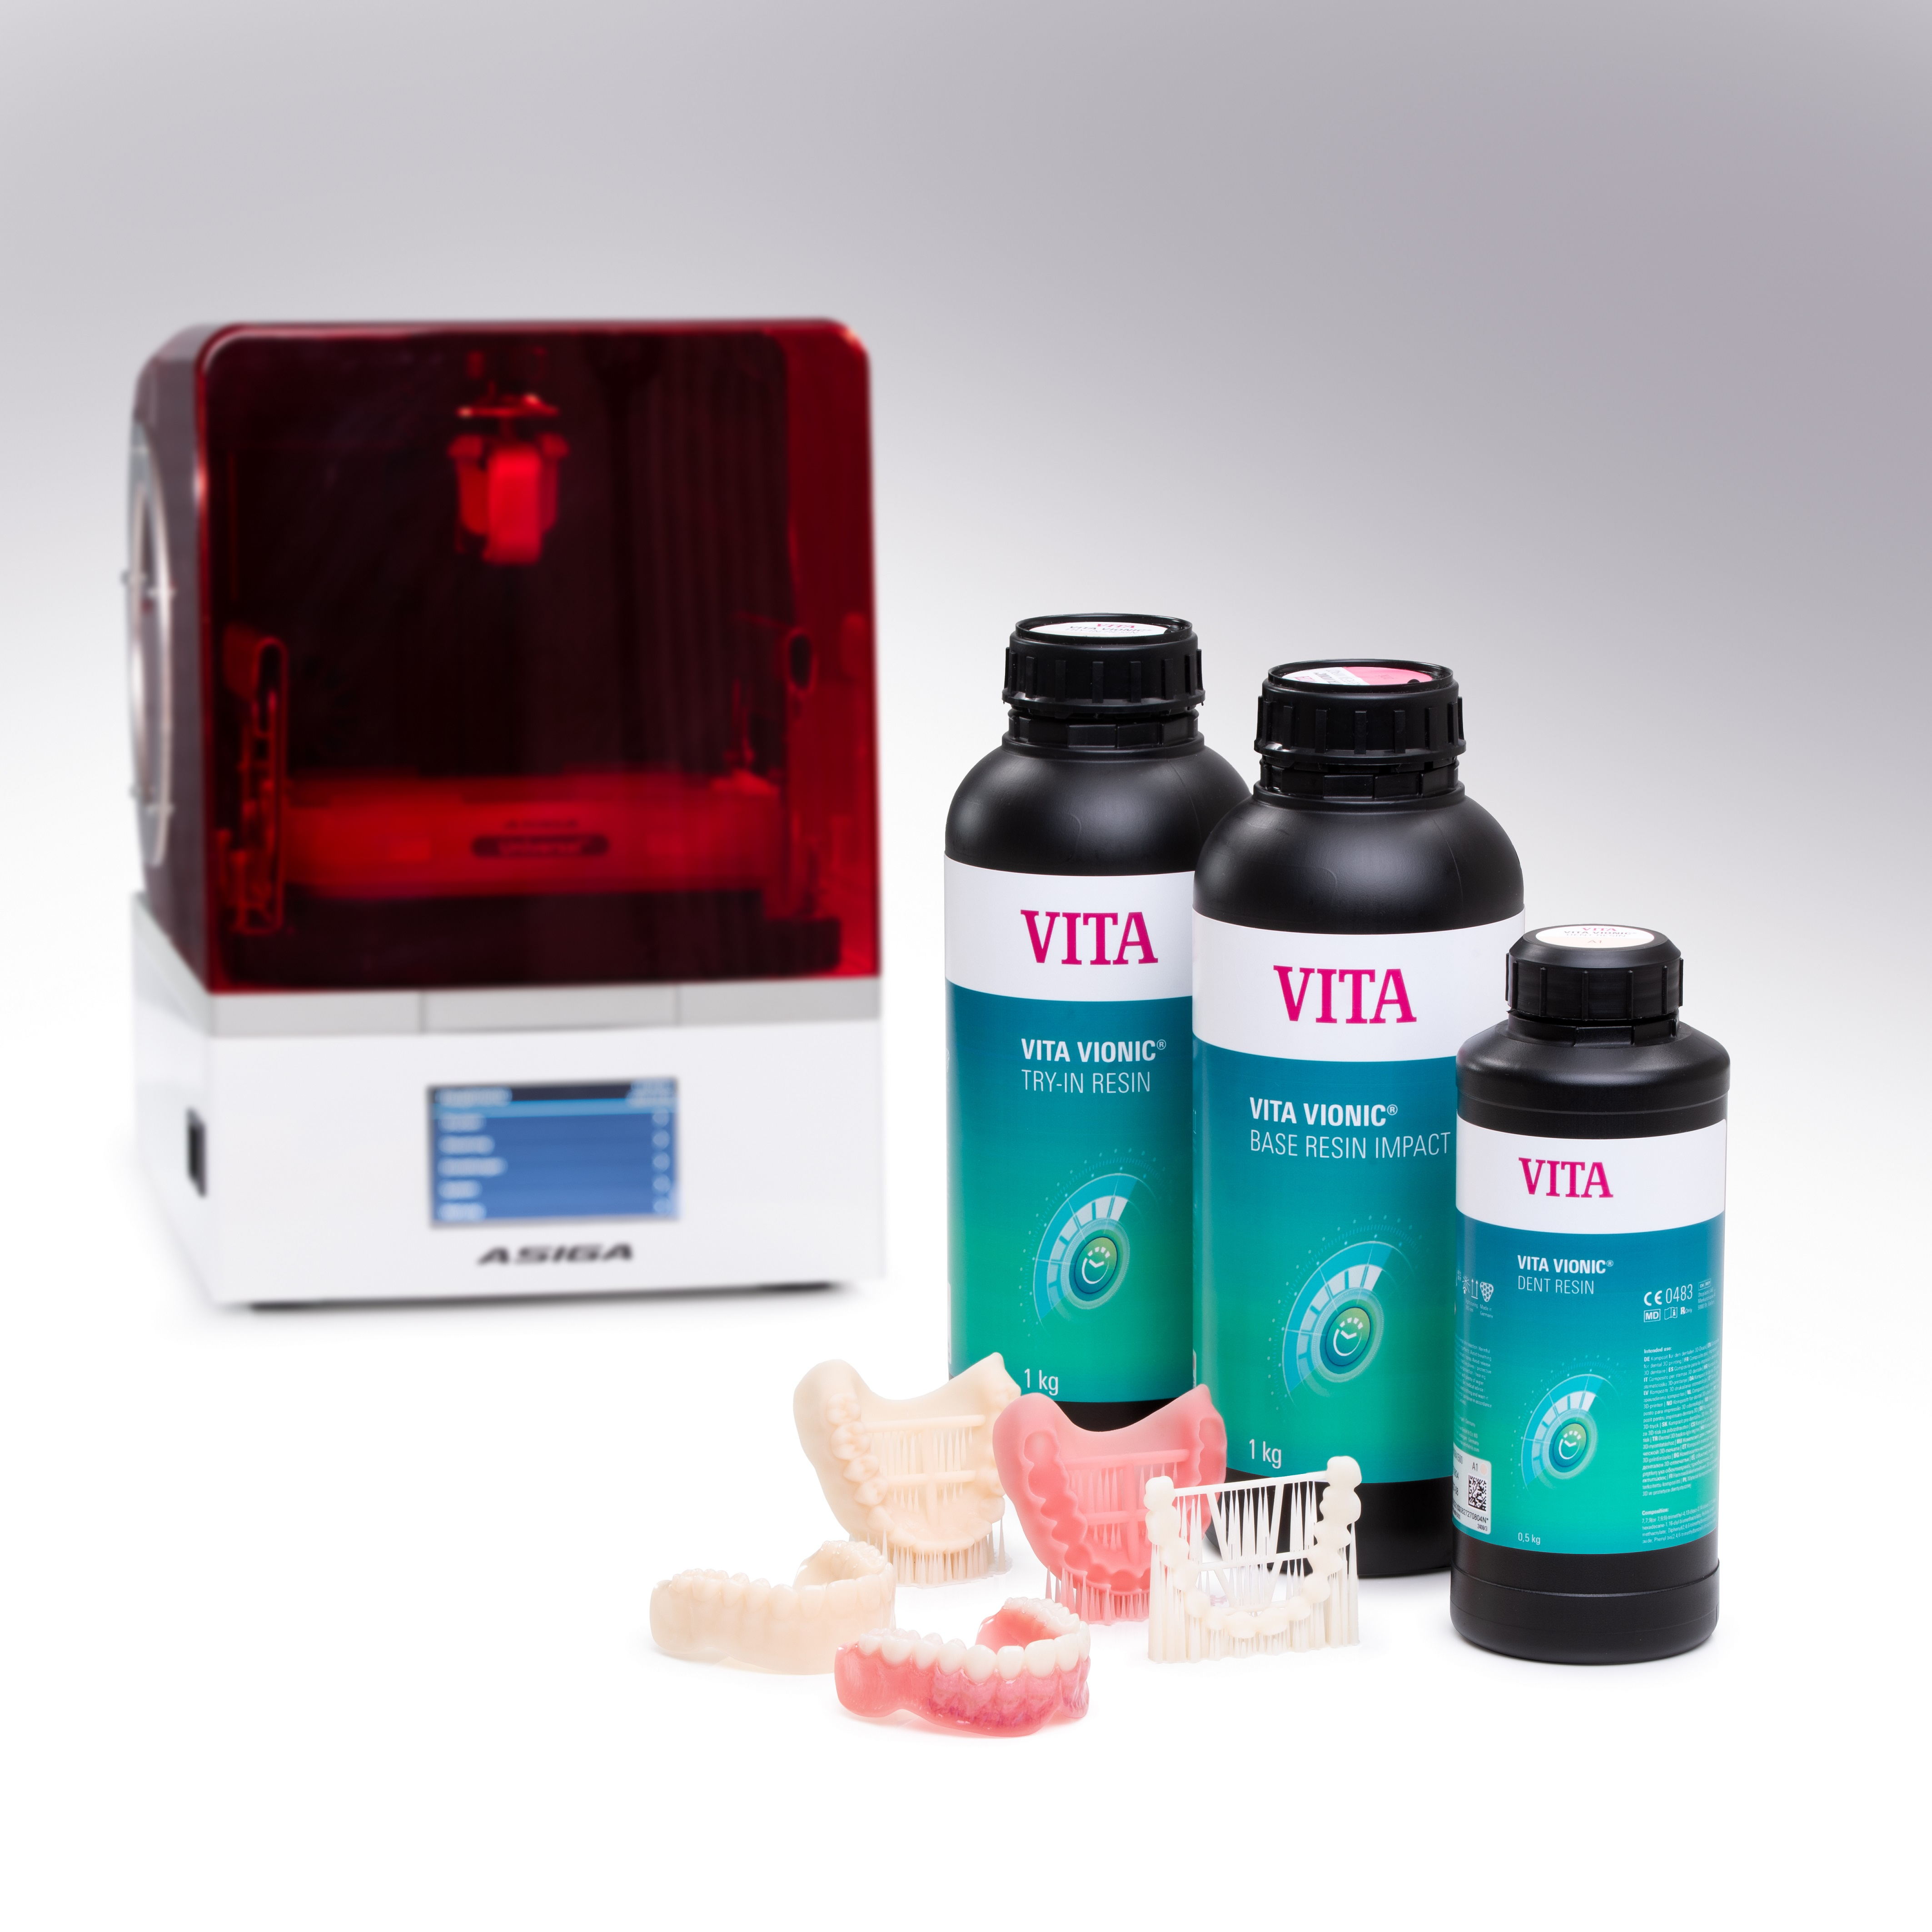

Fig. 1: The new VITA VIONIC TRY-IN RESIN, VITA VIONIC BASE RESIN IMPACT and VITA VIONIC DENT RESIN

VITA Zahnfabrik H. Rauter GmbH & Co. KG
VITA Zahnfabrik H. Rauter GmbH & Co. KG is a fourth-generation family business in the dental industry based in Bad Säckingen, in southern Germany. For over 100 years, VITA has been developing, producing and distributing innovative, high-quality products and solutions for dental technology and dentistry. Worldwide, more than 600 employees work for VITA Zahnfabrik, with the objective of being closer to users and customers than anyone else. Areas of expertise range from analog and digital shade determination, denture teeth and veneering materials, press ceramics and CAD/CAM materials and furnaces and dental materials.
The needs of the user are also the focus of the new development of innovative system solutions for the functional and esthetic reproduction of tooth structure. With scientific expertise and targeted training programs, VITA supports and advises dental experts from more than 125 countries in their daily work.
This "PERFECT MATCH" can be experienced in the lab and practice, from precise tooth shade determination to the finished restoration and cementation. VITA Zahnfabrik consistently pursues a path of excellence in developing better solutions for ideal prosthetics with continuous innovation and high-quality standards. In doing so, VITA Zahnfabrik offers innovative restoration options that contribute to an enhanced quality of life.

