June 2024
Products & Services
VITABLOCS TriLuxe forte: Premium esthetics with even more options

Quality "made in Germany" for exactly 100 years: With its product portfolio, VITA Zahnfabrik offers highly esthetic solutions for prosthetics. The same applies to the proven VITABLOCS TriLuxe forte CAD/CAM blocks. Just in time for the 100th anniversary, the blocks are now available in five new VITA classical A1-D4 shades.
Esthetics and proven high quality
With its integrated shade gradient, VITABLOCS TriLuxe forte is especially suitable for CAD/CAM fabrication of crowns and veneers in the visible area. The four intensity layers guarantee a natural interplay of color and light – as close to the esthetics of natural teeth as possible.
Proven feldspar ceramic – for over 35 years
This material has a special fine structure, which is proven to make it exceptionally easy to polish, as well as resistant to abrasion. Numerous clinical studies confirm the long-term durability of restorations using VITABLOCS.
Simple and efficient to use
VITABLOCS TriLuxe forte will also be available in the shades B1, B2, B3, C2 and C3, in addition to the VITA classical shades A1, A2, A3 and A3.5 already available. This gives users even more options for quickly and easily creating restorations with matching shades.
VITABLOCS TriLuxe forte also saves time and makes the workflow more efficient. A chairside treatment in just one session at a dental practice is easily possible using VITABLOCS. Patients not only benefit from the fast treatment, but also from the highly esthetic results.
More on VITABLOCS TriLuxe forte
Additional information: www.vita-zahnfabrik.com/vitablocs_TP6_Multicolor.html
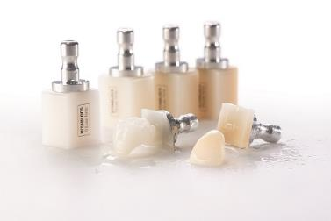
Fig. 1: VITABLOCS TriLuxe forte makes efficient CAD/CAM restorations possible with impressive results.

VITA Zahnfabrik H. Rauter GmbH & Co. KG
VITA Zahnfabrik H. Rauter GmbH & Co. KG is a fourth-generation family business in the dental industry based in Bad Säckingen, in southern Germany. For 100 years, VITA has been developing, producing and distributing innovative, high-quality products and solutions for dental technology and dentistry. Worldwide, more than 600 employees work for VITA Zahnfabrik, with the objective of being closer to users and customers than anyone else. Areas of expertise range from analog and digital shade determination, denture teeth and veneering materials, press ceramics and CAD/CAM materials and furnaces and dental materials.
The needs of the user are also the focus of the new development of innovative system solutions for the functional and esthetic reproduction of tooth structure. With scientific expertise and targeted training programs, VITA supports and advises dental experts from more than 125 countries in their daily work.
This "PERFECT MATCH" can be experienced in the lab and practice, from precise tooth shade determination to the finished restoration and cementation. VITA Zahnfabrik consistently pursues a path of excellence in developing better solutions for ideal prosthetics with continuous innovation and high-quality standards. In doing so, VITA Zahnfabrik offers innovative restoration options that contribute to an enhanced quality of life.

