June 2025
Products & Services
VITA and UP3D: Validated Workflow for Highest Demands

Bad Säckingen/Shenzhen, June 2025 – Digital collaboration continues to advance: VITA Zahnfabrik H. Rauter GmbH & Co. KG (Bad Säckingen, Germany) and UP3D Tech Co., Ltd (Shenzhen, China), a rapidly growing provider of digital CAD/CAM system solutions, now offer a fully validated workflow for dental milling applications.

At the heart of this new partnership lies the successful validation of VITA’s complete CAD/CAM material portfolio on the UP3D milling machine series – including the models P42, P53 and P55D. This allows dental laboratories and clinics to work with a fully harmonized system – from material selection to final restorations. The validation covers the full range of VITA CAD/CAM materials – from the million-times proven feldspar VITABLOCS, the high-performance VITA YZ zirconia, and the unique VITA ENAMIC hybrid ceramic to the VITA VIONIC materials for digital denture production. This ensures not only reliable results, but also restorations that meet the highest standards of esthetics and functionality.

UP3D is known for delivering powerful yet attractively priced CAD/CAM systems with a strong and growing global customer base. In combination with VITA’s proven materials, this creates a forward-looking solution that is simple, efficient, and validated.
This validation marks another important step toward open, workflows optimized for industrial application - that ensure process safety at every stage. Users benefit from coordinated parameters, smooth processes, and consistent quality.

About VITA Zahnfabrik
VITA Zahnfabrik H. Rauter GmbH & Co. KG, based in Bad Säckingen, Germany, is a global leader in innovative dental materials and technologies. For over 100 years, the VITA brand has stood for quality, user-focused solutions, and pioneering developments in dental technology and dentistry.

About UP3D
UP3D is an innovative high-tech company headquartered in Shenzhen, China, with subsidiaries in the USA, Italy, and Japan. UP3D specializes in the development and manufacturing of comprehensive digital CAD/CAM system solutions for dentistry. UP3D provides fully integrated, in-house solutions – from advanced scanning technology and CAD software to high-performance milling machines.

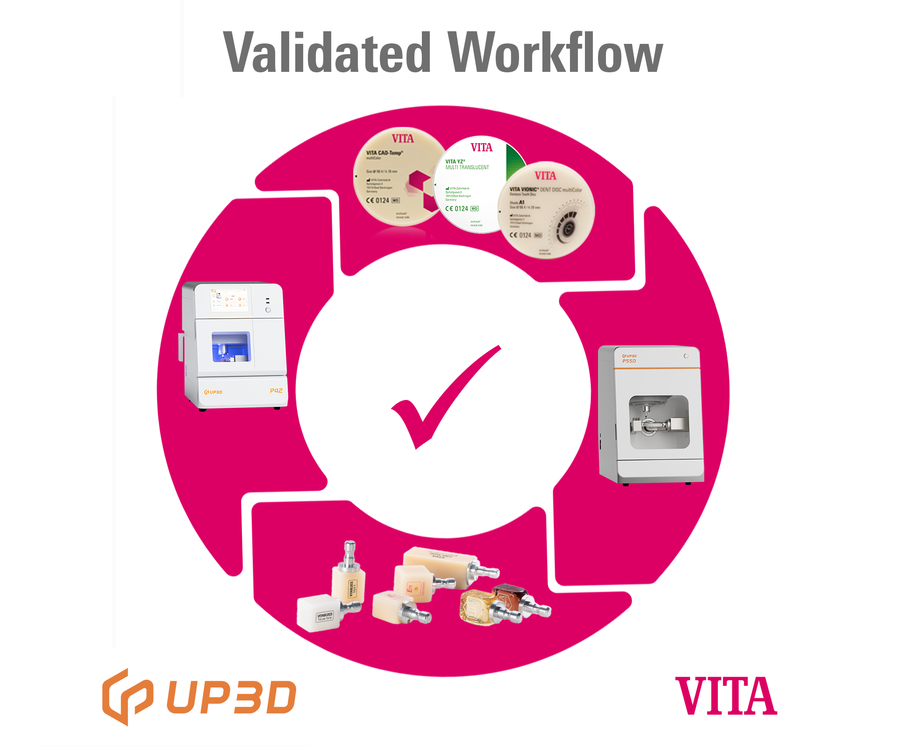

Fig. 1: VITA and UP3D: Validated Workflow for Highest Demands

UP3D Tech  401, Block B, Nanshan Yungu Nanfeng Tower  Nanshan District, Shenzhen, China  +86 755 26983202  https://www.up3dtech.com/  Sales Inquiries  info@up3dtech.com  Press Contact  Lydia Lu  marketing@up3dtech.com | VITA Zahnfabrik H. Rauter GmbH & Co. KG  Spitalgasse 3  79713 Bad Säckingen  +49 7761 562-0  www.vita-zahnfabrik.com  Sales Inquiries  info@vita-zahnfabrik.com  Press Contact  Giulia Mazzullo  g.mazzullo@vita-zahnfabrik.com

